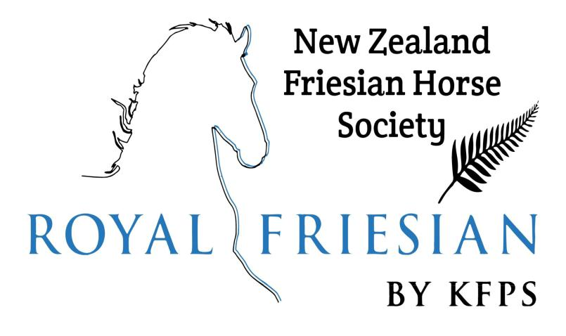

New Zealand Friesian Horse Society Inc:

2022 High Points Awards

CLOSING DATE FOR 2022 AWARDS IS: 8th of April 2022

We would like to encourage all members to get out to various events or just out and about with their Friesians and to enter the NZFHS HPA (high point award) competition. This is a free competition open to all NZFHS members –help us to grow these awards by entering your horse.
The HPA runs each calendar year (Jan 1st through to Dec 31st ). These awards are designed to recognise owners for every discipline or just for fun.; We all want to promote the Friesian breed.
There are a variety of categories in the HPA competition to suit everyone.
6 Best results of shows or competitions per calendar year are valid for each category, and each result qualifies for only one category allocation of points (e.g: cannot nominate one outing as both a ridden dressage test and a demonstration)

- Dressage

- Driving

- Showing (ln hand, Ridden and Driving)

- Pleasure

- And demonstration

An electronic scorecard can be downloaded from the NZFHS Inc website https://nzfhs.co.nz/

Explanation of Rules:

Show Classes including ln hand, Ridden and Driven classes:
Score cards have to be signed by an official or secretary of the show for points to be awarded.
Evidence from an official show website showing horse's placings will also be accepted. Here is how HPA points a re calculated. Attendance in open classes = 2 points (each horse will get 2 attendance points regardless of what place it may receive in the class).
First place= 6 points
Second place= 5 points Third place= 4 points Fourth place= 3 points Fifth place = 2 points Sixth place = 1 point
Attendance in Purebred Friesian classes = 1 point (each horse will get 1 attendance point regardless of what place it may receive in the class).
First place =3 points

Second place = 2 points Third place = 1 point

New Zealand Friesian Horse Society Inc:
2022 High Points Awards

CLOSING DATE FOR 2022 AWARDS IS 8th of April 2022

Our Categories and their Sponsored Trophies are:

DRESSAGE | - | Sponsored by The Hungry Horse Cafe
SHOWING | - | Sponsored by the NZFHS Inc.
DRIVING | - | Sponsored by Glenrose Friesians

FRIESIAN SPORTHORSE CROSS - Sponsored by Limbrook Friesians These points are allocated for open and purebred classes:

Supreme Champion = 4 points Reserve Champion = 3 points

National Championships = triple points

State Championships/ Royal show= double points Agricultural show or local show= single points

Pleasure outing = 5 points

Pleasure horse category points are to be awarded on photo evidence of a ·member's horse with two or more other horses, a social outing (Trek , pleasure ride with 2 or more horses, riding or driving club outing or event etc...)

Demonstration or Display= 10 points

Demonstration points will be awarded on evidence of an article or photograph which shows the horse taking part on the day of the demo or promotional day (Santa parade, horse expo driven or ridden demonstration, on any public outing other than a show class.)

Dressage: Points are awarded by the percentages earned by the horse on the dressage test sheet and test sheets must be supplied with the completed HPA scorecard each year . Horses competing at FEI level will receive double points on their score percentages.

Between 60 to 61.999% = 1 point Between 62 to 63.999% = 2 points Between 64 to

65.999% = 3 points Between 66 to 67.999% = 4 points Between 68 to 69.999% = 5 points Between 70 to 71.999% = 6 points 72% and over= 7 points.

PLEASE NOTE: Scorecards MUST be completed along with all associated
paperwork/requirements and lodged by the Friday 8th of April 2022 to: ……

Any questions please don't hesitate to contact us:Please support these awards - they are for you and your Friesian Horse!

Bronie - treasurer@nzfhs.co.nz & Baldeep - bdhillon@bigbarrel.co.nz

