The NZFHS HIGH POINTS AWARD is available to all Friesian horses of any age owned by a member of the New Zealand Friesian Horse Society.

High points will be awarded from the beginning of each calendar year, January to December, and score cards must be returned no later than Friday, 8th of APRIL, 2022. For results and prizes to be announced at the following NZFHS AGM. (Awards will be posted to those unable to attend the AGM).

Show Classes: Score cards have to be signed by an official or secretary of the show for points to be awarded. Printed evidence from an official show website showing horses placing will also be accepted.
Pleasure horse category points are to be awarded on photo evidence of a members horse with two or more other horses a social outing (Trek, pleasure ride with 2 or more horses, riding or driving club outing or event )
Demonstration points will be awarded on evidence of an article or photograph which shows the horse taking part on the day of the demo or promotional day ( Santa parade, horse expo driven or ridden demonstration, any public outing other than a show class.) Roll Of Merit points will be calculated and added each year to the horse’s lifetime achievements in its various disciplines. Awards are: ROM, Bronze, Silver, Gold & Platinum.
Send or e mail completed cards to:
bdhillon@bigbarrel.co.nz & treasurer@nzfhs.co.nz

Horse’s Gender:

Horse’s Registered Name:

Owner Name & Phone Number:

Registration Number:

Member Number:

Scorecard 2022 HPA
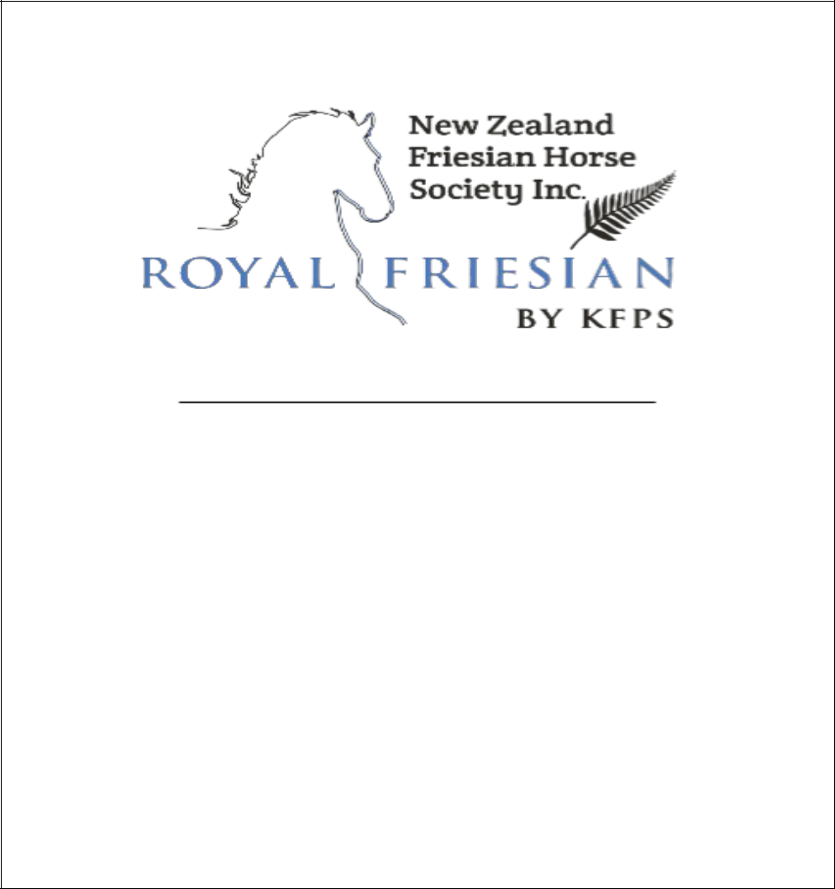

Note: Score cards must be returned via email, fax,
or post to arrive no later than
Friday 8th April 2022
If you have any questions please don’t
hesitate to contact us:
Bronie YUCEL
treasurer@nzfhs.co.nz
Baldeep Dhillon
bdhillon@bigbarrel.co.nz

Date

Event

Name of
Rider/Handler

In Hand

Ridden

Driven

Demo

Pleasure

Place

Show Official
Signature

