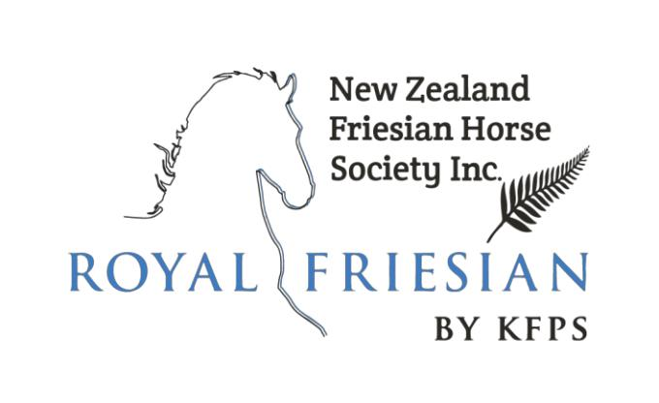

Order form DNA Test

The undersigned hereby request the KFPS to conduct DNA tests at the Van Haeringen Laboratorium in Wageningen, The Netherlands

The DNA test applies to

☐Dwarfism, hydrocephalus and chestnut factor*

☐Paternity test*

Use hair samples from the KFPS data base if they have been supplied at registration*

☐Hair samples enclosed*

- Please tick where appropriate Name horse: Click here to enter text. Registration number: Click here to enter number. Name: Click here to enter text.

Member number: Click here to enter number.

Address: Click here to enter text.

City: Click here to enter text. Postcode: Click here to enter number.

The fully completed document with the inclusion of hair samples can be sent by mail or if hair samples are already supplied you can email this document. Send to the NZFHS registrar, details below. The result of the test will only be made available on the KFPS website, using my KFPS.

_______________________________________________________________________________________________

Registrar: Sandy Nogueira, PO Box 21135, Henderson, Waitakere, Auckland, email registrar@nzfhs.co.nz Ph: 021755592
http://www.nzfhs.co.nz/ © 2021 NZFHS & KFPS
Page 1

DNA Test Payment form

Payment (tick applicable boxes) Please check the latest fees on our website.

Total amount paid: ____________

I have attached a cheque

I have deposited the amount in the NZFHS account– please write below

date ___________ payment name/description: ___________________________________

Account 12 3211 0027717 00

Registrar: Sandy Nogueira, PO Box 21135, Henderson, Waitakere, Auckland, email registrar@nzfhs.co.nz Ph: 021755592
http://www.nzfhs.co.nz/ © 2021 NZFHS & KFPS
Page 2

