The NZFHS Inc High Points Awards (HPA) are available to all Friesian horses of any age owned by a member of the New Zealand Friesian Horse Society.

High Points Awards run from 1st April to 31st March. This year’s score cards must be returned no later than Wedneday 30th April 2026. Results and prizes will be announced at the upcoming NZFHS Inc AGM (Date to be confirmed). Awards will be posted to those unable to attend the AGM.

HPA Categories and Sponsored Trophies:

DRESSAGE Sponsored by The Hungry Horse Café
DRIVING Sponsored by Glenrose Friesians
SHOWING Sponsored by the NZFHS Inc.
PLEASURE/CTR/WE Sponsored by Willowdale Ranch
DEMO/DISPLAY Sponsored by the NZFHS Inc.
FRIESIAN SPORTHORSE X Sponsored by Limbrook Friesians
E-mail completed HPA cards to Linda Gowdy at: web@nzfhs.co.nz
Owner’s Name:

Owner’s Contact Number:

Owner’s Mailing Address:
Horse’s Registered Name:

Horse’s Gender:

Horse’s Registration Number (if known):

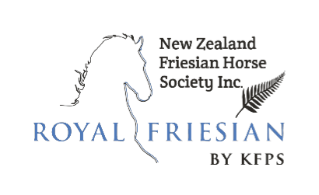

2025-2026 HPA Scorecard

Note: Scorecards must be returned via e-mail
to Bronwyn Yucel at
web@nzfhs.co.nz
to arrive no later than
Wednesday 30th April 2026

If you have any questions please don’t
hesitate to contact us.

Date | Event | Name of Rider/Handler | Award Category (eg. in-hand show, CTR, dressage) | Location | Show Official Signature

