The NZFHS Inc High Points Awards (HPA) are available to all Friesian horses of any age owned by a member of the New Zealand Friesian Horse Society.

High Points Awards run from 1st April to 31st March. This year’s score cards must be returned no later than Tuesday 30th April 2024. Results and prizes will be announced at the upcoming NZFHS Inc AGM on Saturday 4th May 2024. Awards will be posted to those unable to attend the AGM.

HPA Categories and Sponsored Trophies:

DRESSAGE Sponsored by The Hungry Horse Café
DRIVING Sponsored by Glenrose Friesians
SHOWING Sponsored by the NZFHS Inc.
PLEASURE/CTR/WE Sponsored by Willowdale Friesians
DEMO/DISPLAY Sponsored by the NZFHS Inc.
FRIESIAN SPORTHORSE X Sponsored by Limbrook Friesians
E-mail completed HPA cards to Bronwyn Yucel at: treasurer@nzfhs.co.nz
Owner’s Name:

Owner’s Contact Number:

Owner’s Mailing Address:
Horse’s Registered Name:

Horse’s Gender:

Horse’s Registration Number (if known):

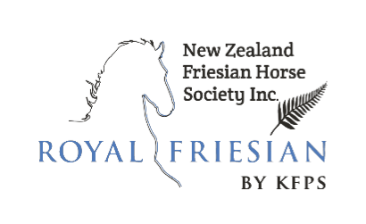

2024 HPA Scorecard

Note: Scorecards must be returned via e-mail
to Bronwyn Yucel at
treasurer@nzfhs.co.nz
to arrive no later than
Tuesday 30th April 2024

If you have any questions please don’t
hesitate to contact us.

Date | Event | Name of Rider/Handler | Award Category (eg. in-hand show, CTR, dressage) | Location | Show Official Signature

