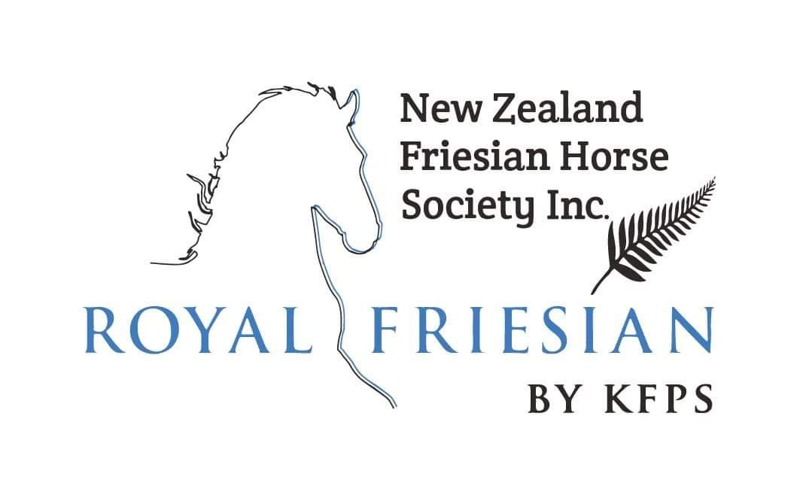
ORDER FORM FOR DNA TEST
(Please tick where appropriate)

The undersigned hereby request the KFPS to conduct DNA tests at the Van Haeringen Laboratorium in Wageningen, The Netherlands.

The DNA test applies to:
☐ Dwarfism, hydrocephalus and chestnut factor
☐ Paternity test
Use hair samples from the KFPS database if they have been supplied at registration
☐ Hair samples enclosed

Horse’s Name
Registration Number
Name
Member Number
Address

The fully completed document with the inclusion of hair samples needs to be sent my mail to the NZFHS Registrar. If hair samples have already been supplied, the document can be e-mailed. The result of the test will only be made available on the KFPS website, using myKFPS.
Please check the latest fees on our website: www.nzfhs.co.nz

Total amount to be paid: $________

Once we have received and approved your Order Form for DNA Test, we will provide you with our society’s bank account details so that you can transfer the correct amount into it.

