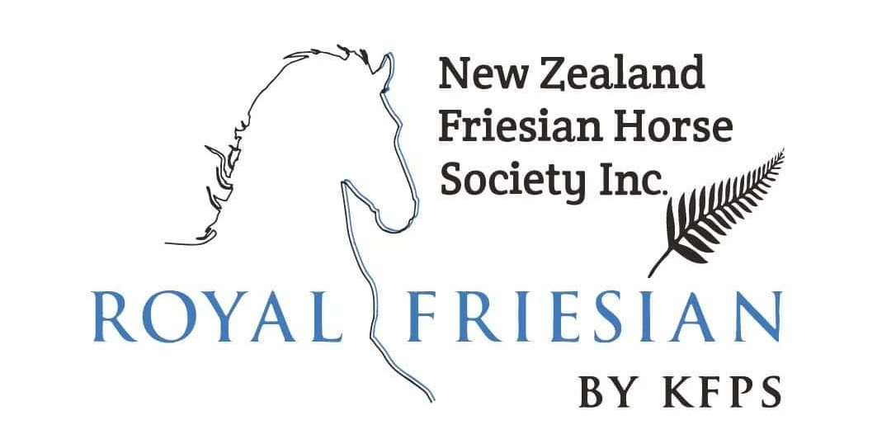

MEMBERSHIP APPLICATION FORM
Please fill out clearly and mail or e-mail to the Secretary.

Name
Stud Name (if applicable)
Address
Mobile |  |  |  | Phone
E-mail |  |  |  | Website (if applicable)
☐ (Please tick.) I agree to receive New Zealand Friesian Horse Society (NZFHS) e-mails/newsletters containing news, updates and information regarding awards, events, inspections and other NZFHS activities. You can withdraw your consent at any time.
NZFHS Member Type  (please tick appropriate) |  | ☐ Social Member $30  ☐ Full Member (New) $190  ☐ Full Member (Renewal) $120  ☐ Phryso Magazine $153 |  |  | ☐ Stud Name Protection (New Application) $119  ☐ Stud Name Renewal Fee $32
Please note: To be eligible to attend a Keuring you must be a full member of the NZFHS in the year of AND the year prior to the Keuring taking place, with the exception of new members.
Signature
Date

PAYMENT
Once we approve your membership application, we will provide you with our society’s bank account details so that you can transfer the correct amount for your membership.

