The NZFHS Inc HIGH POINTS AWARD for the year 2022 is available to all Friesian horses of any age owned by a member of the New Zealand Friesian Horse Society.

High points will be awarded from the beginning of each calendar year, January to December 2022, and score cards must be returned no later than Saturday 20th of May 2023. Results and prizes will be announced at the following NZFHS Inc AGM. Awards will be posted to those unable to attend the AGM. (AGM date to be announced soon.)

Show Classes: Score cards have to be signed by an Official or Secretary of the show for points to be awarded. Printed evidence from an official show website showing horses placing will also be accepted.

Pleasure horse category points are to be awarded on photo evidence of a members horse with two or more other horses a social outing (trek, pleasure ride with two or more horses, riding or driving club outing or event).

Demonstration points will be awarded on evidence of an article or photograph which shows the horse taking part on the day of the demo or promotional day (eg. Santa parade, horse expo driven or ridden demonstration, any public outing other than a show class).

Roll of Merit points will be calculated and added each year to the horse’s lifetime achievements in its various disciplines. Awards are: ROM, Bronze, Silver, Gold & Platinum.

E-mail completed HPA cards to Bronwyn Yucel at: treasurer@nzfhs.co.nz

Horse’s Gender:
Horse’s Registered Name:

Owner’s Name

Owner’s Contact Number:

Registration Number:

Member Number:
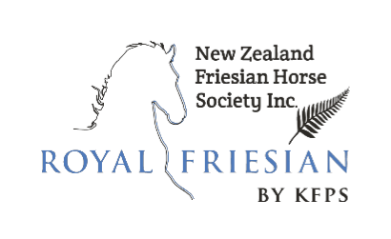

2022 HPA Scorecard

Note: Scorecards must be returned via e-mail
to Bronwyn Yucel at
treasurer@nzfhs.co.nz
to arrive no later than
Saturday 20th May 2023

If you have any questions please don’t
hesitate to contact us.

Date (2022) | Event | Name of Rider/Handler | In-Hand | Ridden | Driven | Demo/Display | Pleasure Outing | Location | Show Official Signature

