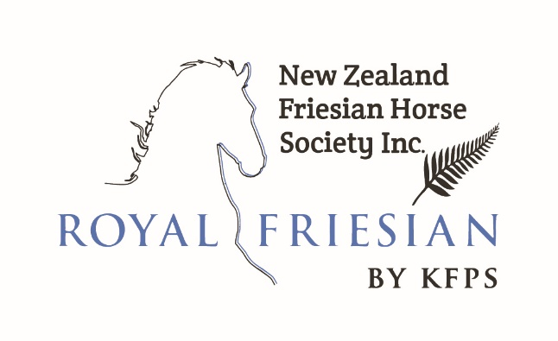
PROXY FORM
FOR VOTING At 2022 NZFHS Inc. AGM

I / (we) __________________________________________________________________________

Being a Full Financial Member of the New Zealand Friesian Horse Society Inc. in good standing and entitled to vote, hereby appoint(s)

(Please tick) - Person you would like to represent you:

__________________________________________________________________________________
- As my (our) proxy

OR

(Please tick) - The chairperson of the meeting - as my (our) proxy

To attend and vote for me (us) at the 2022 (Annual) General Meeting of the New Zealand Friesian Horse Society to be held on the 7th day of May 2022, and at the adjournment thereof with the same power as if I (we) were present at the said meeting or adjournment.

Signature of Member/s _________________________________________ Date: ________________

Signature of Member/s _________________________________________ Date: ________________

Please Note (NZFHS Inc. constitution):

- The instrument of proxy shall be signed under the hand of the appointer. A person appointed by proxy need not be a full member.

- The instrument of proxy shall be deposited with the Secretary no later than 23rd of April 2022 for proper verification otherwise it shall be invalid.

Return: to Secretary before: 23rd of April 2021 - via email.

Secretary NZFHS Inc.
Neil Fremaux
Email: secretary@nzfhs.co.nz

